Landing Page:

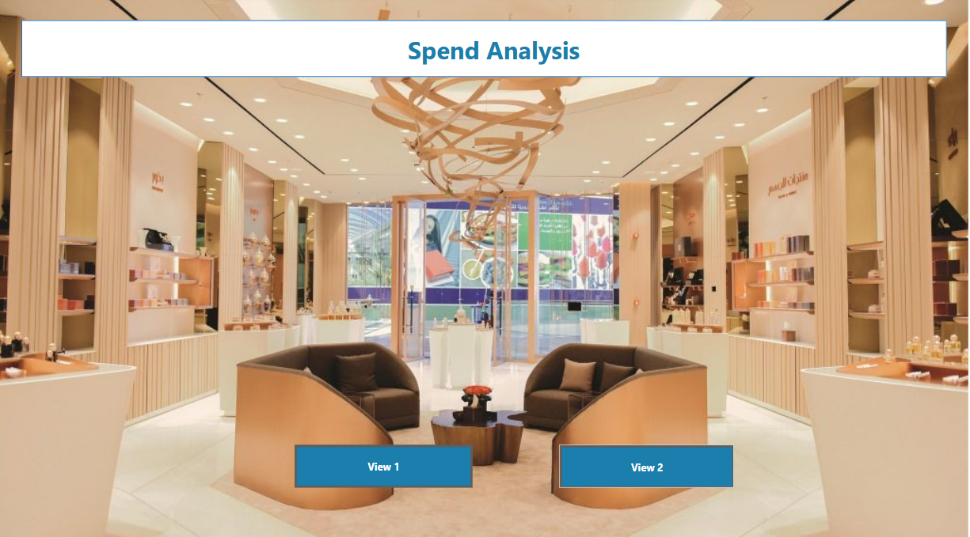

View 1:

View 2:

